**FUNDAMENTALS OF PROGRAMMING**

**HOMETASK NUMBER 2**

**NAME :IFRA MURTAZA**

**CLASS:ME 15**

**SECTION:A**

**CMS ID:454546**

**INSTRUCTOR:MUHAMMAD AFFAN**

1. **Create a program that takes a student's score as input and assigns a grade based on predefined criteria using logical operators (e.g., A, B, C, D, F).**

**A-Grade: 90-100 Marks B-Grade: 75-90 Marks**

**C-Grade: 60-75 Marks D-Grade: 45-60 Marks**

**F-Grade: 0-45 MarksCODE:**

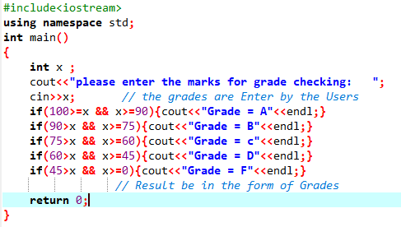

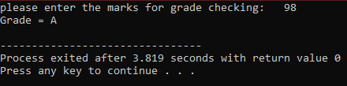**RESULTS:**

**2. Write a program that takes an integer as input and determines if it is both even and divisible**

**by 5.**

**CODE:**

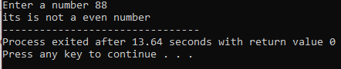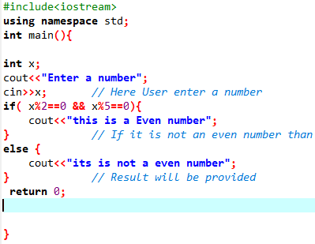**RESULT:**

**3.Create a C++ program that checks if a user-provided year is a leap year.**

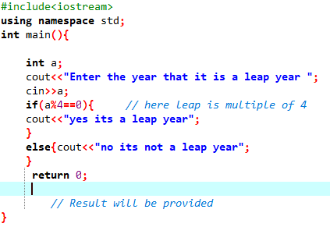**CODE:**

**RESULT:**

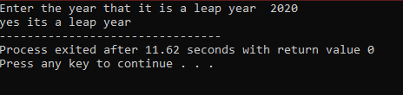

**4. Create a C++ program that determines if a student is eligible for a scholarship based on their**

**GPA (must have GPA >= 3.5) and attendance (must have attended at least 80% of classes).**

**CODE;**

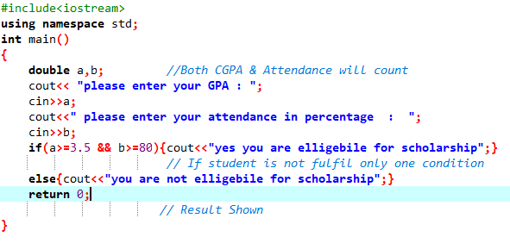

**RESULT:**

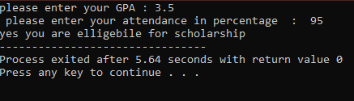

**5. Write a program that checks if a given character is a vowel (a, e, i, o, u) or a consonant using**

**logical operators.**

**CODE**

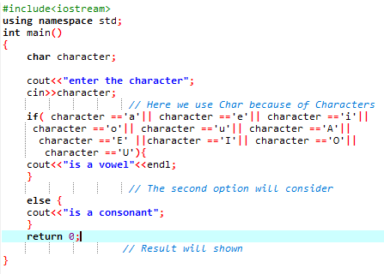

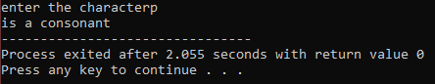**RESULT**